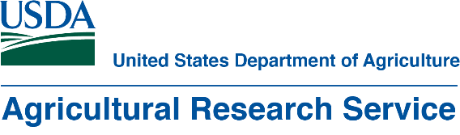

Student Research Intern Position
The USDA-ARS Animal Metabolism-Agricultural Chemical Research in Fargo, ND is recruiting for a student research intern for the summer of 2024. The salary will be $ 15.10-16.91/hr for students (GS-3) who have completed at least one year of college. This is a temporary federal position for eight weeks with sick/annual leave and paid holidays. This is a full time (40 hours/week) position.

The position will focus on the development of detection technology for the chemical contaminant, perfluoroalkyl substances (PFAS), in water. PFAS are detected ubiquitously in environmental matrices. Plants and animals’ can uptake PFAS from the environment and bioaccumulate in their tissues. Humans get exposed to PFAS mainly via drinking PFAS-contaminated water or eating PFAS-contaminated animal- or plant-based food. PFAS exposure may cause adverse health impacts in humans; therefore, it is currently routinely screened by regulatory agencies in different environmental matrices, including water, soil, biosolids, and sludge. The current detection technology involves the use of sophisticated instrumentation with low turnover and expensive assays. Thus, it is critical to develop rapid, inexpensive, field-based technology that detect PFAS in water.

The specific project activities along with the skill development (learning goal) include:
- Generate the experimental data using analytical instruments including UV-Vis and fluorescence spectrophotometers and differential scanning calorimeters to optimize the colorimetric-based assays for PFAS detection. The intern will gain appropriate laboratory and instrumental expertise and learn safe laboratory practices.
- Prepare the written document by reporting the data for result analysis. This will teach the intern not only the interpretation of the experimental data using statistical analysis but also the writing skills.
- Compare the experimental data with the literature data to understand the effectiveness of optimized conditions and discuss the results in a weekly group meeting. The provided opportunity will assist in the development of presentation and professional skills.

Basic experience in word processing and spreadsheet/database programs is required, and
Introductory college courses (> 12 credit hr) in chemistry, pharmaceutics, animal science, environmental science, and/or other closely related fields of study. A valid driver’s license and U.S. citizenship is required. Students from under-represented groups are encouraged to apply.

Applications are due by noon Tuesday, April 30, 2024 and interviews will be held virtually the following week. Please email applications with a subject line of ‘Student Intern Position’ and include a brief cover letter expressing interest in the position, resume (with contact information, statement of U.S. citizenship, work history, education and other relevant experiences, and references), and a copy of unofficial transcripts, if applicable.

Apply to:
Dr. Anuradha Singh, Research Chemist, 701-239-1205, anuradha.singh@usda.gov

